# Bahria University,

## Karachi Campus



COURSE: SEL-401

CLOUD COMPUTING

TERM: SPRING 2024, CLASS: BSE- 6(B)

Submitted By:

Muhammad Shoaib Akhter Qadri_____________79290___

(Name) (Reg. No.)

Submitted To:

Engr. Noor us Sabah / Engr. Muhammad Faisal

Signed Remarks: Score:__

INDEX

|  |  |  |  |  |
| --- | --- | --- | --- | --- |
| SNO | DATE | LAB NO | LAB OBJECTIVE | SIGN |
| 01 | 15/02 | 01 | Introduction to Cloud Computing |  |
| 02 | 22 / 02 | 02 | CREATING VIRTUAL MACHINE USING MICROSOFT AZURE |  |
|  |  |  |  |  |
|  |  |  |  |  |
|  |  |  |  |  |
|  |  |  |  |  |
|  |  |  |  |  |
|  |  |  |  |  |
|  |  |  |  |  |
|  |  |  |  |  |
|  |  |  |  |  |
|  |  |  |  |  |

# Bahria University,

## Karachi Campus



LAB EXPERIMENT NO.

**_02_**

LIST OF TASKS

|  |  |
| --- | --- |
| **TASK NO** | **OBJECTIVE** |
| 01 | Create Windows Virtual Machine in Azure. |
| 02 | Install different software on the created VM (including VS Code and Dev++). |
| 03 | Create simple login and sign up page on VS Code using VM. |
|  |  |
|  |  |
|  |  |
|  |  |
|  |  |
|  |  |
|  |  |
|  |  |

Submitted On:

Date: 15/02/2024

**Task No 01:** Create Windows Virtual Machine in Azure.

**Solution:**

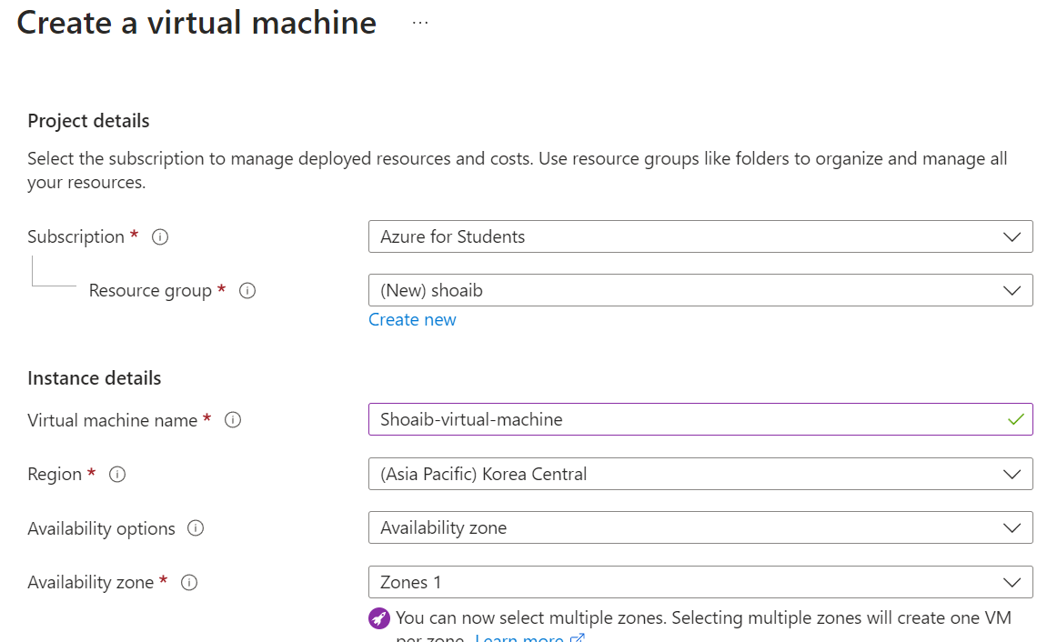

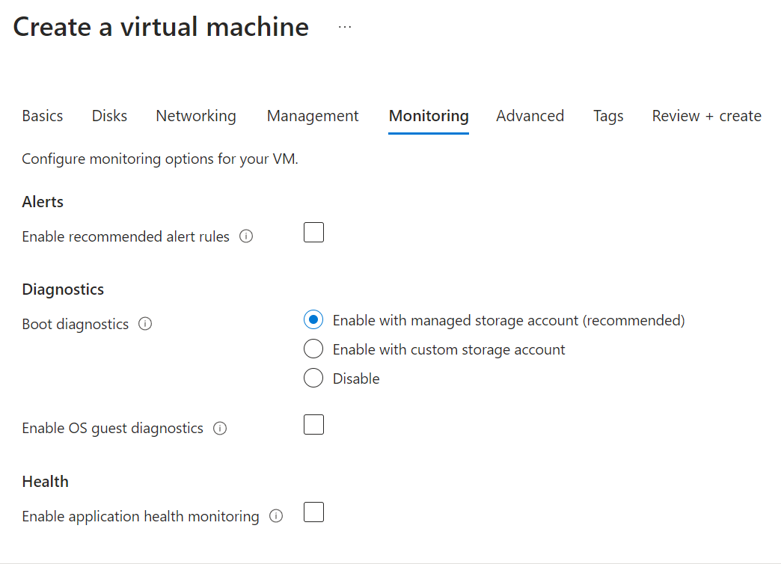 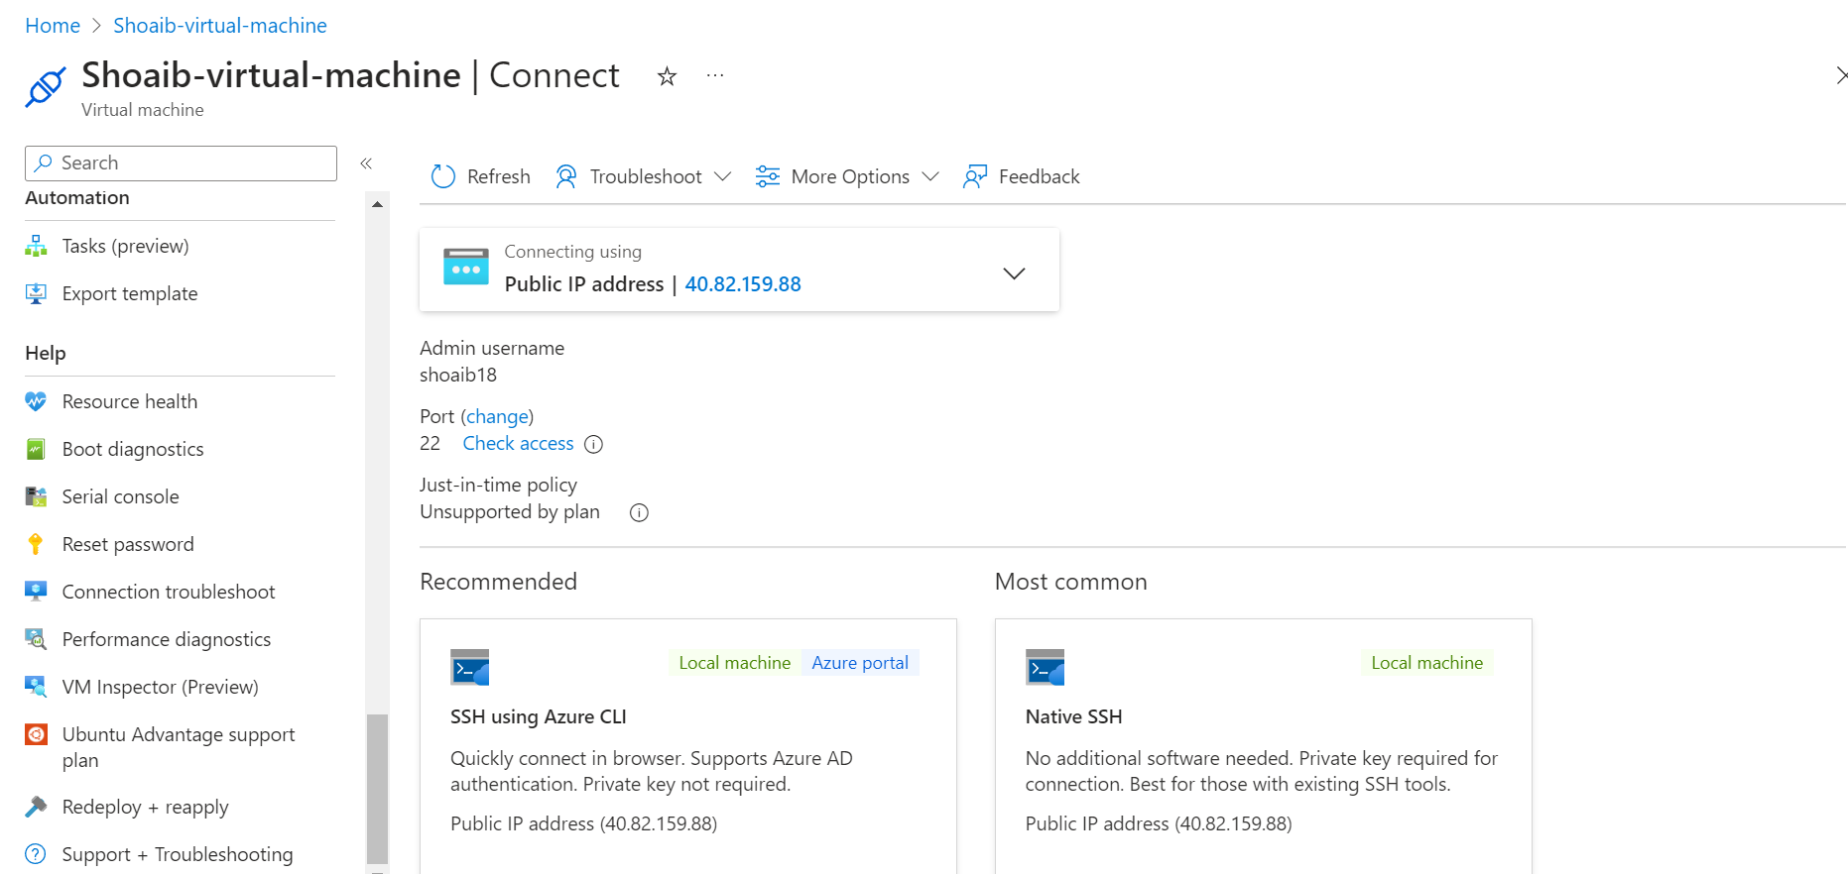

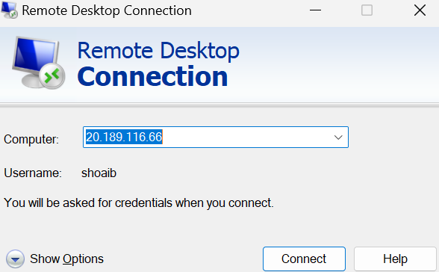

**Task No 02:** Install different software on the created VM (including VS Code and Dev++).

**Solution:**

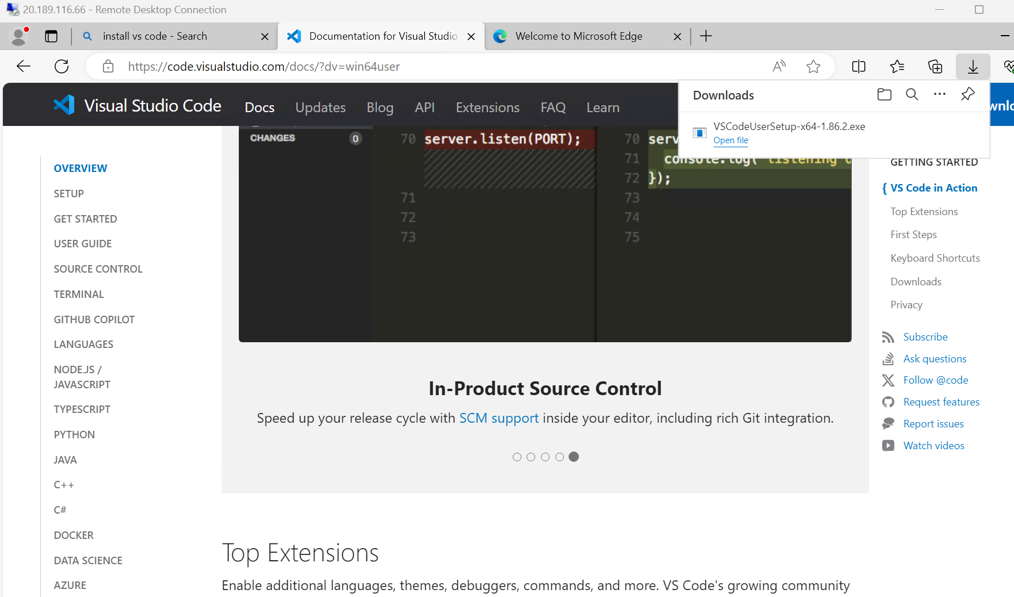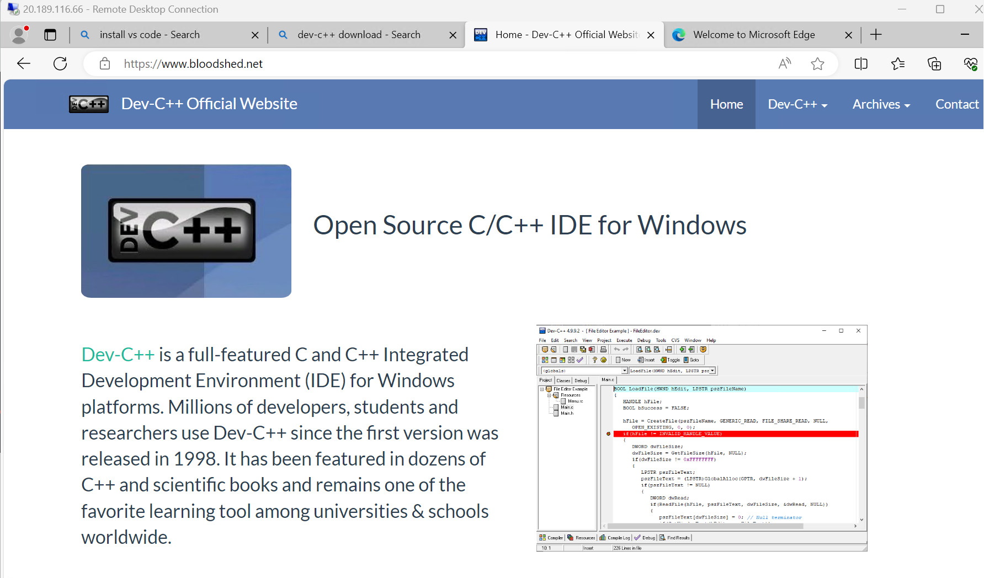

**Task No 03:** Create simple login and sign up page on VS Code using VM.

**Solution:**

<!DOCTYPE html>

<html lang="en">

<head>

<meta charset="UTF-8">

<meta name="viewport" content="width=device-width, initial-scale=1.0">

<title>Login and Signup Page</title>

<style>

    body {

        font-family: Arial, sans-serif;

        margin: 0;

        padding: 0;

        background-color: #f0f0f0;

        display: flex;

        justify-content: center;

        align-items: center;

        height: 100vh;

    }

    .container {

        background-color: #fff;

        border-radius: 8px;

        padding: 20px;

        box-shadow: 0 0 10px rgba(0, 0, 0, 0.1);

        width: 300px;

    }

    h2 {

        margin-bottom: 20px;

        text-align: center;

    }

    input[type="text"],

    input[type="password"],

    input[type="submit"] {

        width: 100%;

        padding: 10px;

        margin-bottom: 15px;

        border: 1px solid #ccc;

        border-radius: 5px;

        box-sizing: border-box;

    }

    input[type="submit"] {

        background-color: #007bff;

        color: #fff;

        cursor: pointer;

    }

    input[type="submit"]:hover {

        background-color: #0056b3;

    }

    .login-link {

        text-align: center;

    }

    .login-link a {

        color: #007bff;

        text-decoration: none;

    }

    .login-link a:hover {

        text-decoration: underline;

    }

</style>

</head>

<body>

<div class="container">

    <h2>Login</h2>

    <form id="loginForm">

        <input type="text" name="username" placeholder="Username">

        <input type="password" name="password" placeholder="Password">

        <input type="submit" value="Login">

    </form>

    <div class="login-link">

        <a href="#" id="signupLink">Don't have an account? Sign up</a>

    </div>

</div>

<script>

    document.getElementById("signupLink").addEventListener("click", function(event) {

        event.preventDefault();

        document.getElementById("loginForm").reset();

        document.querySelector("h2").innerText = "Sign Up";

        document.querySelector("input[type='submit']").value = "Sign Up";

        document.querySelector(".login-link").innerHTML = '<a href="#" id="loginLink">Already have an account? Login</a>';

        document.getElementById("loginLink").addEventListener("click", function(event) {

            event.preventDefault();

            document.getElementById("loginForm").reset();

            document.querySelector("h2").innerText = "Login";

            document.querySelector("input[type='submit']").value = "Login";

            document.querySelector(".login-link").innerHTML = '<a href="#" id="signupLink">Don\'t have an account? Sign up</a>';

        });

    });

</script>

</body>

</html>

**Output:**

